1. Create on Bash script to check if a directory is available or not.

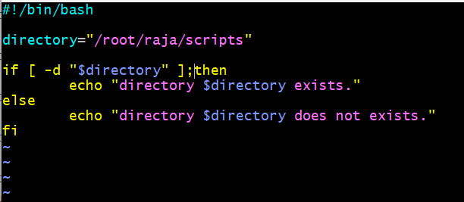

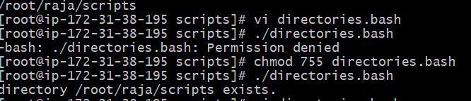

1. Create a bash script which will create multiple files.

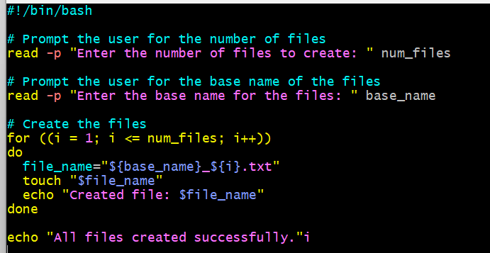

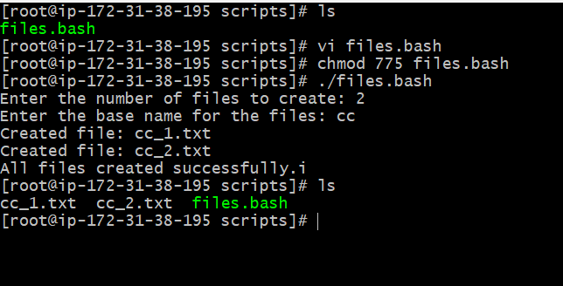

1. Create a bash script to take backup of a directory.

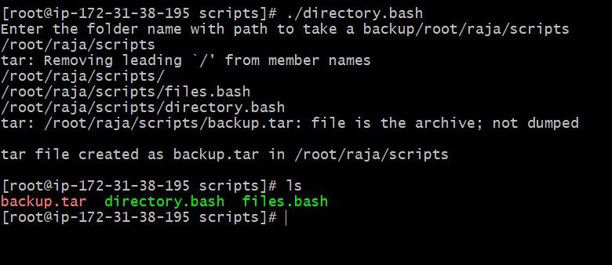

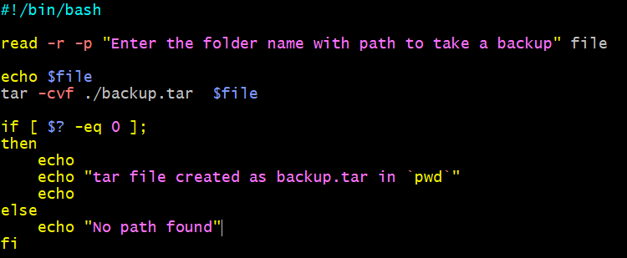

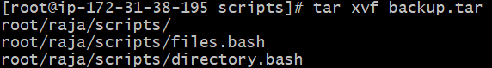

4) Create a bash script to install nginx in ec2 server.